Sign up screen Done

register, check mobile number

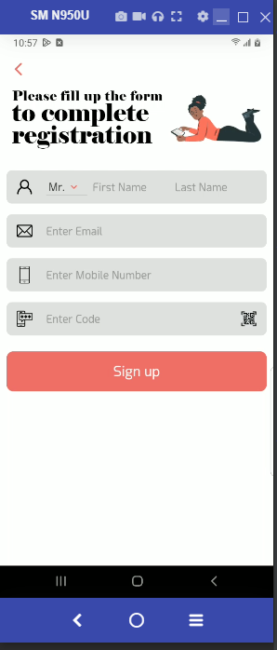

Login screen Done  
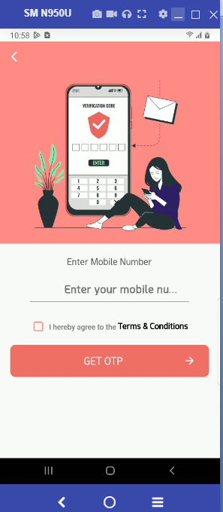

Otp screen Done

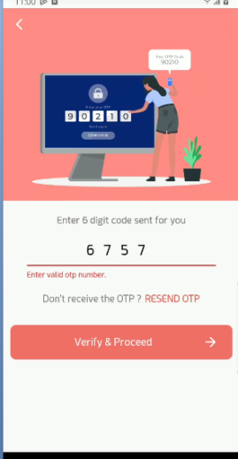

Home screen

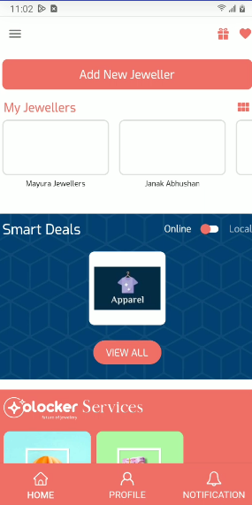

1 jeweler Done

2.add jeweler Done

3 smart deals Done

4 offline deals Done

5 Benner

Jeweler point screen

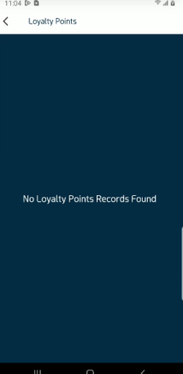

Favorites screen

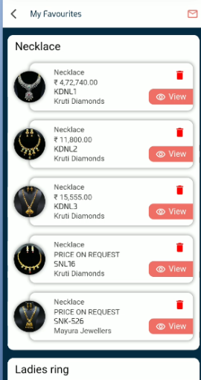

Jeweler jewelry screen

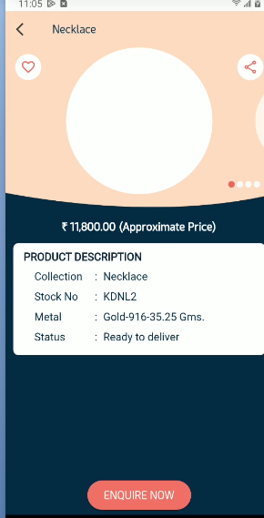

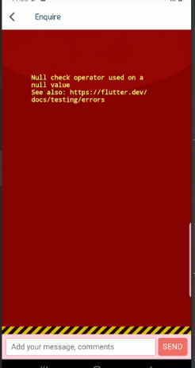Inquire screen

My inquire screen  
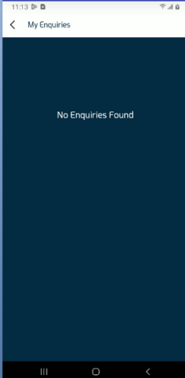

No data

Profile screen Done

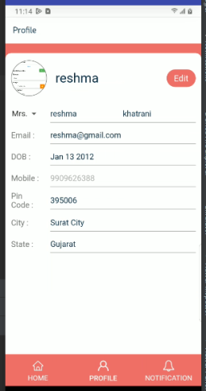

Notification screen

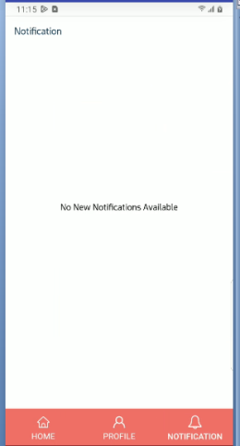

No data

Add Jeweler screen Done

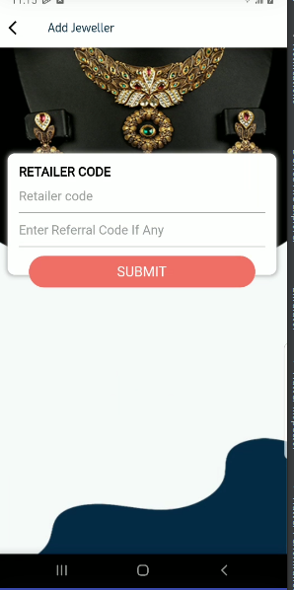

My insured jeweler

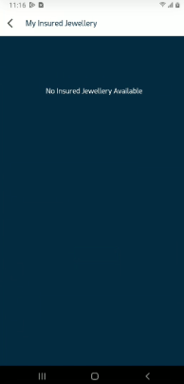

No data

My saving screen

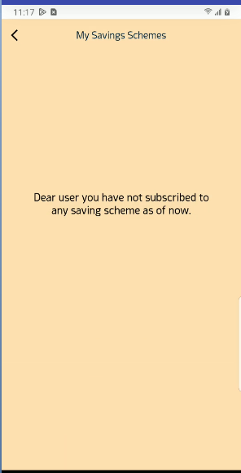

Favorite’s deals

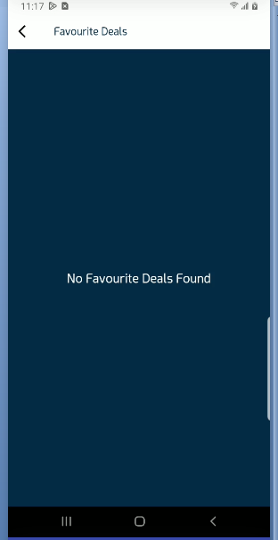

No data

Loyalty points

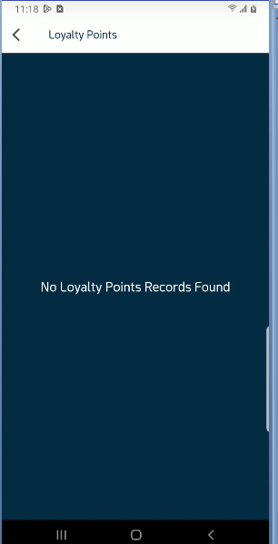

NO data

Add uninsured jeweler Done

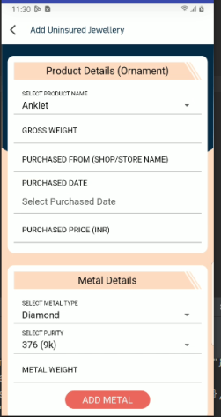

My insured jeweler

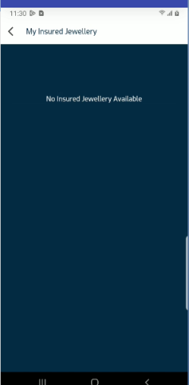

No data

Emi on jeweler

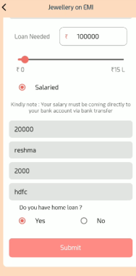

Details screen

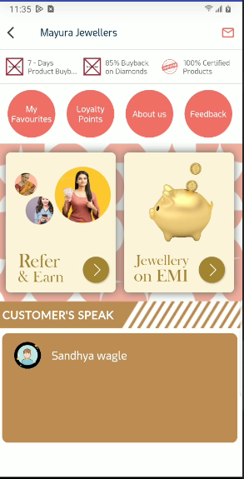

1 GetSpecialFeatures Done

2 GetAnnouncementOffer data get empty

3 GetPushToAppData error

4. GetDetails Done

5 GetUniqueList error

5. GetBestSellerProducts 404

6 GetClientTestimonials Done

7 GetIBJARatesByPartnerId Done

About us screen

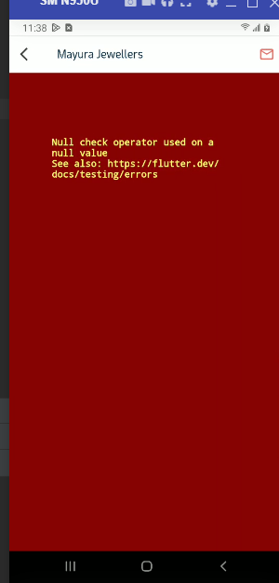

Feedback screen

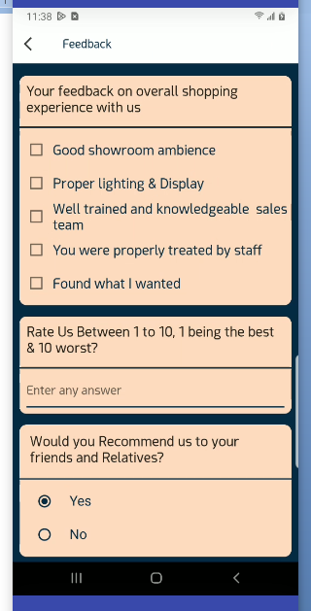

Get done

Add error

Saving shames screen

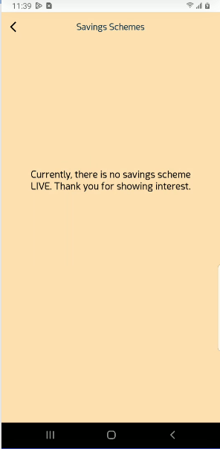

No data

Refer & Earn

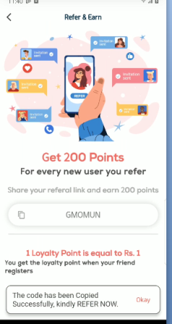  
Get done

Share error

Logout Done

Online deals Done

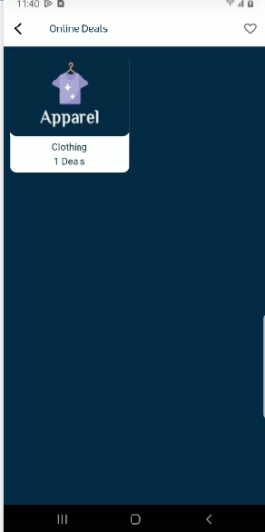

OnlineDealsListScreen screen

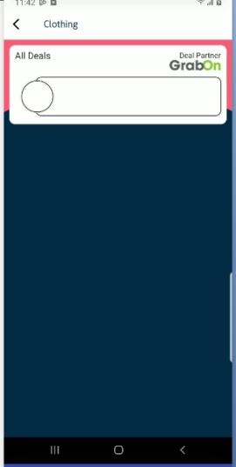

Data null get

OnlineDealsDetailsScreen Done

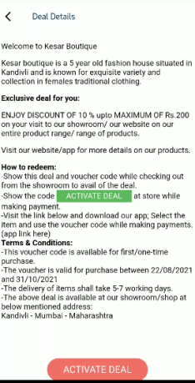

My jeweler portfolio

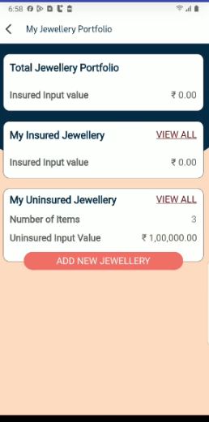

Add , edit uninsured jeweler

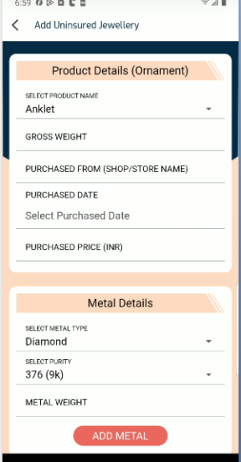

My jeweler jewellery

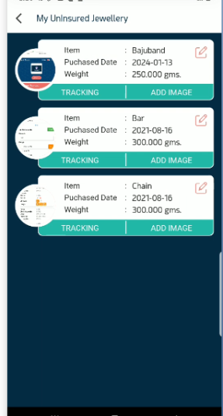

Ornament regnaise

